Task 5
Gap Analysis Report
Topic: Environmental Toxicity (UG Level)
Program: B.Sc. Biotechnology / Environmental Science
Framework Used: Understanding by Design (UbD) – Stage 1
1. Purpose of the Gap Analysis
To identify gaps between the intended learning outcomes (UbD Stage 1) and the current learner preparedness and instructional practices, and to recommend targeted improvements.
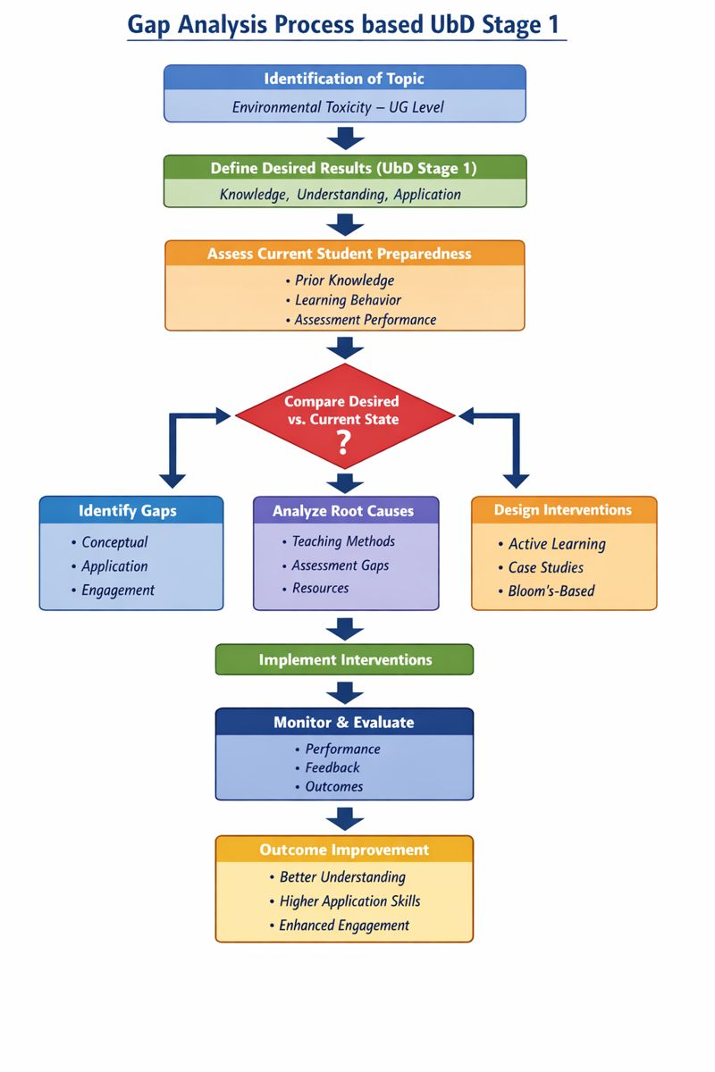
``

2. Desired Learning Outcomes (UbD Stage 1 Summary)
Students should be able to:
- Understand basic concepts of environmental toxicity and common toxicants.
- Explain the effects of toxic substances on organisms and ecosystems.
- Apply fundamental toxicological principles to simple environmental scenarios.

3. Current State Analysis
- Students demonstrate basic awareness of environmental pollution but lack conceptual clarity in toxicological terms.
- Limited ability to relate theoretical concepts to real-world environmental problems.
- Predominant reliance on rote learning with minimal application-based assessment.

4. Identified Gaps and Analysis
Area | Desired State (UbD) | Current State | Identified Gap
Conceptual Knowledge | Clear understanding of environmental toxicants and mechanisms | Fragmented factual knowledge | Incomplete conceptual foundation
Conceptual Understanding | Ability to explain ecological and health impacts | Superficial explanations | Limited depth of understanding
Application Skills | Application of concepts to real-life cases | Difficulty in interpreting scenarios | Weak application skills
Student Engagement | Active learner participation | Passive learning patterns | Low engagement
Assessment Alignment | Bloom’s-aligned assessment (R–U–A) | Recall-heavy evaluation | Misalignment with learning outcomes

5. Root Causes of Gaps
- Overemphasis on lecture-based teaching.
- Insufficient use of contextual and case-based examples.
- Lack of formative assessments targeting Apply-level learning.
- Limited integration of real-world environmental issues.

6. Recommended Interventions
Gap Area | Recommended Strategy | Expected Outcome
Conceptual Clarity | Use visual aids, concept maps, and short retrieval activities | Improved understanding
Understanding Level | Introduce guided discussions and examples | Deeper comprehension
Application Skills | Case studies and scenario-based questions | Enhanced application ability
Engagement | Active learning and peer instruction | Increased participation
Assessment | Bloom’s-aligned question design | Outcome-driven evaluation

7. Expected Impact
- Improved alignment between intended outcomes and learner performance.
- Enhanced student ability to explain and apply environmental toxicity concepts.
- Evidence-based improvement in learning outcomes for institutional reporting.

8. Conclusion
The gap analysis highlights the need for stronger alignment between UbD Stage 1 outcomes and instructional as well as assessment practices. Addressing these gaps through active, Bloom’s-aligned strategies is expected to improve learner engagement and achievement at the UG level.

